2021/22

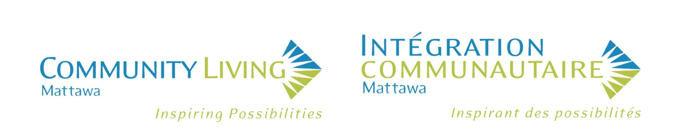

ANNUAL REPORT

Vision Statement

That all people are treated with respect, and live and participate as valued members of the community.

Mission Statement

To support people with developmental disabilities in living independently and participating fully in their community.

Our Values

Awareness – We value the education of the community on the rights and contributions of people with developmental disabilities and the services available through Community Living Mattawa.

Communication – We value the sharing of ideas and concerns in a manner that is respectful, open, honest, two-way, non-judgmental, and is in a language that is understood by everyone.

Inclusiveness – We value a community that accepts and includes everyone equally.

Individual Choice – We value the right for all people to make their own educated choices and to make decisions about the supports and services they receive.

Integrity – We value a workplace where services are provided in a manner that is honest, truthful, and respectful.

Partnerships – We value meaningful connections with others within our community.

Respect – We value the appreciation of all people’s abilities, qualities, characteristics, and goals.

Teamwork – We value working together to achieve a common goal (our Mission).

Board Chair 2021-2022 Annual Report

Good evening and welcome to Community Living Mattawa’s 2022 Annual General Meeting. Thank you for being here tonight with us.
I am honoured to serve as the Chair of the Community Living Mattawa Board of Directors. This past year we welcomed Sabrina Poullas to our Board and tonight welcome Sabrina to her first Annual General Meeting. Sabrina brings a wealth of knowledge to our Board, and we are very pleased that she has joined us.
The volunteer Board of Community Living Mattawa is comprised of seven members from various backgrounds with a wide range of knowledge and experiences. The Board is responsible for the overall performance of the Association as it pertains to policy, finance and achieving its purpose, goals, and objectives.
First and foremost, on behalf of all the members of the Board I would like to sincerely thank and congratulate everyone at Community Living Mattawa who has worked so hard over this past year as the world has continued to learn to live in a global pandemic. All our dedicated staff, from the Executive Director, the Managers, the administrative and finance personnel, the case managers, support workers, and maintenance worker have continued to face every-day challenges with patience, flexibility, professionalism and a “can do” team attitude which has resulted in leading our consumers, their families, and our organization successfully through another difficult year. Thank you so much to each one of you!
The Board would also like to recognize and thank our consumers and their families for their patience and co-operation throughout this past year. We know that the constant changes in Ministry restrictions have resulted in changes to your routines and programming which have been very difficult for all of you, and we thank you for your understanding.
The Board has continued to meet throughout the year either virtually or in-person to carry out its responsibilities. The highlight of this past year was the opportunity to once again be able to host the Annual Christmas Dinner after an absence of two years. All the Board members were touched by the excited looks on our consumers’ faces as they entered the Legion and saw their friends after many had not seen each other for a couple of years. Seeing our consumers and staff hug each other, talk, and laugh together and having the opportunity of delivering gifts to everyone made this a very special evening for all of us!
Over this past year we are also pleased to have been able to assist and support Community Living Mattawa in obtaining a replacement passenger van, approving the completion of the long-delayed renovations to the Brydges residence and begin the gradual transition to technology to assist and streamline administrative and records functions.
I am pleased to say that with the lifting of some provincial restrictions we have resumed planning fundraising activities that will help support Community Living Mattawa activities. We held a successful BBQ in May and a Yard Sale in June and have been selling tickets for our

Board Chair 2022 Annual Report (Cont’d)

50/50 draw. We will be holding another BBQ in August and a Texas Horseshoe Tournament in October. We hope you will buy some tickets and we look forward to seeing you at these events!
Fifty-three years ago, a group of caring and dedicated family and community members in Mattawa opened an Adult Education Centre, which over the years became Community Living Mattawa. Today a different group of individuals are continuing their work with spirit and determination to support and assist Community Living Mattawa and its consumers in continuing its mission to support people with developmental disabilities in living independently and participating fully in their community.

Respectfully submitted
Wayne Cotgreave
Board Chair

Executive Director 2021-2022 Annual Report

Hello, and welcome to Community Living Mattawa’s Annual General Meeting. This year was a challenging year for the agency, as COVID-19 continued to dominate how the agency was able to provide services. The pandemic created numerous obstacles that the agency had to overcome. The agency was short-staffed due to employees being required to self-isolate for COVID-19, services were restricted by rules that prevented people from accessing community activities and events, consumers got sick and needed care, and additional expenses were incurred in order to keep up with the demands of the pandemic. However, even with all of the obstacles faced by the agency, the team at Community Living Mattawa from the Board of Directors down to the frontline employees performed exceptionally well, and maintained the highest standard of care for all of the people supported by the agency.

I would like to start by thanking the employees of the agency. Despite the continued unknown associated with the pandemic, they continued to come to work and perform. The employees worked everyday within the changing rules and guidelines presented by the Ministry and Public Health. They made sure that the people supported in all programs received the care they needed. This included advocating for participation in community activities and creating opportunities for interaction with others whenever possible. This helped maintain both the physical and mental well-being of everyone supported within the agency. The employees continue to challenge and ask questions about when restrictions will be reduced in order to provide a more inclusive life for the people we support. Without this ongoing dedication by the employees, the lives of the consumers would not have been as good as they have been over the past two years.

Executive Director 2021-2022 Annual Report (Cont’d)

The dedication and commitment from the employees cannot be overlooked. This year there are 9 employees being recognized for service awards (5 for 5 years of service, 1 for 10 years of service, 1 for 15 years of service, 1 for 25 years of service and 1 for 30 years of service). The longevity of employment for our employees demonstrates their commitment and care for the people we support and everyone within the organization thanks them for their years of service.

Of particular note of this group of service award recipients is Louise Guilbeault, who retired from CLM this past March after 30 years of dedicated service. Louise worked in our Community Outreach Services, assisting the people we support to learn and apply the skills needed for independence within our community. Louise, had a wonderful relationship with the people she worked with and tried to provide them with unique and new experiences, such as going overnight camping. Louise acted as a mentor for any new employees that started working within the Community Outreach Service and continues to offer her expertise for training of new staff moving into the program as needed. On behalf of everyone at CLM, I thank Louise for her service and wish her all of the best in her retirement.

From and overall staffing perspective, the employer continues to maintain a good working relationship with the workers’ union, the United Steelworkers Union, Local 2020. In September 2021, the Union and the Employer negotiated a new 3-year Collective Bargaining Agreement. The new contract extends to the end of September 2024. Both the Union and the Employer have demonstrated a willingness to cooperate in order to provide the best working environment for all of the members of the Union.

I would like to say a special thank you to the Management Team. This group of professional women worked tirelessly throughout the year to ensure the frontline employees had the resources they needed to provide the best quality services possible, while maintaining Ministry and financial compliance, addressing the various COVID-19 pressures, and ensuring the agency had staff coverage for all areas of the organization, and kept the agency within its approved budget. All of this work happened despite losing two members of the team in the fall, as Marcie Campbell and Kelly Porter left for new opportunities. However, the Management Team was very fortunate to find our newest member, Tanya King, who joined the CLM Management team in November and is making an instant impact amongst the Managers and with the programs she oversees.

I would also like to thank the Board of Directors of the agency. The current Board is made up of a group of caring individuals, that truly have the agency’s best interests at heart. And, though the majority of our meetings were conducted by videoconference, the Board remained engaged and active throughout the year. One of the activities that the Board undertook in February was a review of the agency’s Strategic Plan. The Board reviewed the outcome measures and updated plans on how to achieve the agency’s strategic directives. The incite provided by the Board offered an updated vision of where the agency is going over the next few years.

Unfortunately, due to the pandemic, the agency’s fundraising efforts were limited again this past year. The agency held its annual membership drive which generated 50 personal memberships and 20 corporate memberships. This group of members provides a strong support base for the agency within the community of Mattawa.

Executive Director 2021-2022 Annual Report (Cont’d)

The agency did receive one large donation in 2021. The mother of one of the consumers supported in one of the group homes passed away and she bequeathed a donation to Community Living Mattawa as a way of saying thank you for the care and support her daughter receives and to provide some funding that could be used for the benefit of the consumers across the agency. Decisions are still being made on how best to utilize this generous donation. Moving forward in 2022, CLM is fortunate that the COVID-19 restrictions are lifting and will be able to hold fundraising events again.

Community Living Mattawa’s funding remained stable over the past, but with no base budget increases again in 2021. This continues to challenge the agency to keep up with cost-of-living increases, but everyone works together to ensure the agency stays within budget. One thing the Ministry permitted this past year as a result of the pandemic, was to give agencies financial flexibility. This allowed CLM to move funds back and forth between our Residential Programs and our Community Supports Programs as needed. In addition to our Ministry funding, CLM also received funding from the Nipissing District Social Services Administration Board and the Nipissing Infection Prevention and Control Hub. This funding was dedicated to offsetting the costs of PPE in 2021 and 2022.

In addition to the base funding received from the Ministry in 2021-2022, the Ministry also provided funding for frontline workers. The Ministry recognized the work of the frontline Case Managers, Night Support Workers, and Support Workers and provided them with a temporary wage enhancement of $3.00 per hour. In April 2022, the Ministry passed legislation that made this increase permanent for frontline workers. The increased wage was established to start at the beginning of the 2022-2023 fiscal year. This is great news for the majority of the agency’s frontline workers. Unfortunately, the wage enhancement does not cover all frontline employees, nor does it cover the Administrative Assistant or the Managers. This creates an imbalance within the agency’s pay structure. This is an area that Developmental Services agencies across the Province are advocating to change. But the existing wage enhancement is a good first step to increasing wages within the Developmental Services sector.

Community Living Mattawa continued to meet its Ministry mandate to have the capacity to provide services in French. Using the updated policy as a guide, CLM improved its consumer intake process by actively asking new consumers in what language they would like to receive service. More in-depth training was also provided to new consumers on what is available to them in French and staff training increased the information employees received about French-language services offered within the agency. Our plan continues to develop as implementation slowly takes place across the agency. Strides will continue to be made toward making French Language Services more readily available within the agency.

Community Living Mattawa completed their annual Ministry Compliance inspection in September 2021. The inspection was an abbreviated assessment due to COVID-19. The inspector conducted the inspection virtually. Using the computer, the inspector was able to inspect both of the group homes and all of the necessary files and policies she needed. CLM passed its compliance inspection with no items requiring follow up. The Case Managers that assisted with the inspection did a great job providing the information the inspector needed. Starting April 1st, the full inspections are being re-implemented, so when the agency receives its notice for its next inspection, it will be for the full pre-pandemic inspection.

Executive Director 2021-2022 Annual Report (Cont’d)

As the agency continues to move through, hopefully the end of, the pandemic, the agency is slowly providing more opportunities for the people we support to join community activities and events. People have, once again, started playing darts at the Royal Canadian Legion, swimming at the YMCA, and attending the dances at the Golden Age Club. It is great that opportunities are finally opening up again, allowing everyone to participate in the community.

CLM will face more challenges in the coming year, but I believe with the excellent team in place from the Board of Directors, to the Management Team, to the frontline employees, Community Living Mattawa will continue to provide high quality services that create the environment for everyone to become an independent and fully participating member of our community.

Respectfully Submitted by:
David Spencer
Executive Director

Community Services Manager 2021-2022 Annual Report

It is with great pleasure that I present to you the Community Services Annual Report.
This past year has been enlightening as much as it has been challenging. Though the pandemic has left its mark, these unprecedented circumstances have helped us discover new and different support delivery methods for the people we support. It has driven us to be more flexible and creative!

It never ceases to amaze me how much the people we support can teach us about resiliency, patience and adaptability. They are true champions! With the province finally relaxing some of the pandemic restrictions, the people we support are finally experiencing more freedom within their community. The happiness you see being expressed when someone is able to engage in social settings again is truly touching.

I would like to take this opportunity to recognize the continued dedication and commitment shown by our employees; they are truly astounding. Our employees continue to work through ongoing changes, working hard at maintaining our high standards of health and safety, and providing quality supports and care. Our employees played a huge role in keeping the agency’s essential services operational through this ordeal, and continue to do so. They have managed commendably and such recognition is highly deserved.

Our agency has been impacted by the increased human resource shortages in the workforce affecting our country at this time. Due to these issues, some of our services are unable to operate at full capacity. Families receiving children’s respite funding are still experiencing difficulties recruiting private Respite Workers, and people receiving Passport Funding are encountering the same obstacles. The Management Team and our employees continue to work together to increase recruitment efforts to address this ongoing issue.

Community Services consists of Community Outreach Supports, Transitions Services, Children’s Respite Coordination and Passport Services. Over the las 12 months, Community

Community Services Manager 2021-2022 Annual Report (Cont’d)

Services as a whole had to evolve. In August 2020, we introduced ‘Community Outreach Supports’. The intention and focus of this service was to provide individualized support in a ‘one-on-one’ setting. Over time, it has demonstrated the benefits and importance of providing tailored and individualized supports, which has positively affected those receiving the supports. In May 2021, the service was supporting six people. The service has grown considerably, and is now supporting twenty people! As the Provincial Government continues to reduce gradually its pandemic restrictions, and gradually increase our staffing capacity, we are hoping to expand the service to offer educational workshops as well as additional social and recreational activities.

Our Transition Services are currently supporting two young adults. This service is designed to support adolescents and young adults with a developmental disability, to prepare and plan for their transition from children services to adult services. This consists of supporting them and their caregivers to navigate the application process with Developmental Services Ontario (DSO), the application process with Ontario Disability Support Program (ODSP), and develop a Person Directed Plan. The ultimate end goal is to support them in finding the adult service that will best meet their wants and needs.

In the 2021-2022 fiscal year, Children’s Respite Coordination supported nine children. Due to pandemic restrictions, most of the coordination occurred over the telephone, email and regular posted mail. The annual respite funding re-application process was completed again this year with families over the telephone. Again, we received very positive feedback from them using this method to complete their re-applications. They continued to express that completing the application process over the telephone was more time efficient and even reduced stress in some instances.

Respite families faced several of the same challenges as they did last year, where the pandemic created difficulties in finding suitable Respite Workers to support their children. Many Respite Workers continued to decline providing Respite relief to families, as they were concerned for their personal health and safety. As a result, many families have gone without respite support for long periods. Because of these pressures, families were granted temporary allowances on how they could spend their funding. These allowances gave families the opportunity and flexibility to purchase educational, hobby-related and sensory-type supplies, as these items could provide respite-type activities for their children. Now that the province is relaxing its pandemic restrictions, families are being encouraged to begin using their funding in means that are more traditional. With this change, families will be looking for more support from our agency in trying to recruit and hire private Respite Workers.

It has been another interesting year for Passport Services. In 2020, the Ministry of Children, Community and Social Services temporarily expanded the list of admissible expenses regarding how people’s funding could be spent. Under these temporary measures, people could purchase items that would be of benefit to them while they remained safely at home, while providing the technical means to stay connected to friends and family. People were able to purchase items such as fitness equipment, electronics and technology type equipment and services (such as Internet service), sensory and hobby supplies, and personal protective equipment. The majority of the people we support with their Passport Funding took full advantage of this provision. The Ministry extended these temporary admissible expenses into 2021, and thankfully, they are still in effect for the time being. I am delighted to report the agency is currently supporting 26 people

Community Services Manager 2021-2022 Annual Report (Cont’d)

in Passport Services. As we anticipate this number to continue growing, the agency will be exploring new ways to expand the service’s support delivery capabilities.

The successes we have seen in Community Services this past year are a direct result of the hard work and dedication of the Case Managers and Support Workers. I thank them again for everything they do for the people we support.

Our agency’s Mission is to support people with developmental disabilities live independently and participate fully in their community. I look forward to working with the Community Living Mattawa team over the next year carrying on with this Mission. A new year full of potential and possibilities!

Respectfully Submitted by:
Tammy Boudreau-Bangs
Community Services Manager

Residential Services & Quality Assurance Manager 2021-2022 Annual Report

I would like to take this opportunity to introduce myself, my name is Tanya King and I am the new Residential Services and Quality Assurance Manger. My previous work experience comes from working with Community Living North Bay for 17 years in various programs which assisted me in gaining the experience and knowledge I have today. I am grateful to have been given the chance to be The Accommodations and Quality Assurance Manager for Community Living Mattawa.
Upon starting with Community Living Mattawa a mere 6 months ago, I knew I was venturing into new territory and would have much to learn along the way. This being said, let me share some of my journey with all of you.
Our Brydges residence renovation has been at a standstill since the onset of the pandemic in 2020 however, I am pleased to announce that this renovation commenced May 2nd, 2022 with a completion date of May 7th, 2022. New flooring was installed on the main floor and stairway access to the basement from upstairs was completed, allowing one of the consumers to move their bedroom to the basement level to enjoy more personal space. As an added bonus for the consumers of the Brydges residence, while the renovations were taking place, they enjoyed a much needed vacation to Niagara Falls.
The Supported Independent Living (SIL) Program is now running at full capacity with supports being provided to all consumers within the program, following the lifting of COVID restrictions. Recently we had a vacancy declared in the SIL program but that was filled quickly by a person who required supports to move back to his hometown from North Bay. We have encountered a few hiccups along the way in supporting the new individual, however the team has come

Residential Services & Quality Assurance Manager 2021-2022 Annual Report (Cont’d)

together to ensure he is receiving the best possible supports through our SIL program, family and Community Outreach services.
The generator at the Valois property required an upgrade this winter, as the Generac Switch was not providing adequate power to the building. The switch was changed and upgraded and power now goes to the tenant that lives in the upstairs apartment and the downstairs staff area.
Scheduling has been an ongoing challenge for the agency, consuming a great deal of time to complete each month. Over a three-month period, I researched a few Scheduling programs and contacted the companies to schedule demonstrations. After reviewing a number of companies, we chose GO Easy Care. We are currently in the implementation phase of this new scheduling program. We are hopeful the program will make scheduling easier and will be well received by the employees of the agency. The program is an online platform that will assist not only the Management Team in completing the schedule more efficiently, but will also allow employees to complete shift change requests, and see their schedules online.
Recruitment efforts continue for the agency. Since I started with CLM, we have had one (1) successful part-time Support Worker and two (2) Apprentice Support Workers join our team. CLM held our first of many recruitment days on April 28th, 2022 and we look forward to many more. We had two successful applicants from our first recruitment day and our next recruitment day is scheduled for May 25th, 2022.
CLM is very lucky to have such dedicated employees who always offer assistance when staffing is thin, retention of our employees has been successful given the open communication the Management Team has with them and the flexibility offered to ensure employees are able to balance work and home life. A happy team makes for a successful organization.
Our annual education and training has resumed both online and in small in-class group sessions. Crisis Prevention Intervention (CPI) resumed in-class in January 2022. Surge Learning continues to be the platform for the agency’s online learning. The material has been updated into groups of policies that will be accessed by the employees on a monthly basis. An annual training calendar was established that will provide employees with a month-to-month breakdown of what to expect from Surge Learning training for the entire year. Heartzap has also opened their doors to in-person training for First Aid/CPR with the option of completing the first day online, an option many staff appreciate and utilize.
With the ups and downs of COVID-19, it has certainly been a rollercoaster ride in the past few months. We have been fortunate to have had only one COVID-19 related outbreak, which the employees handled really well.
I have been welcomed with open arms from every consumer that I have had the pleasure of meeting. The employees of Community Living Mattawa have so much passion for their work in

Residential Services & Quality Assurance Manager 2021-2022 Annual Report (Cont’d)

assuring the care, welfare, safety and security of each and every one of the consumers they support directly or indirectly is of the highest quality. In these trying times, the resilience of the employees and consumers needs to be acknowledged and celebrated. Everyone is going above the call of duty in working towards our common goal and Vision “That all people are treated with respect and live and participate as valued members of the community.” I applaud each and every one of them for their efforts and for showing me how fast 6 months can go by when you know that, no matter what, you have an amazing team you can count on.

Respectfully Submitted by:
Tanya King
Residential Services & Quality Assurance Manager

FINANCIAL REPORT ACTIVITIES 2020/21
Audited Financial Statement Available upon Request

Service Awards

Community Living Mattawa would like to recognize and congratulate the following employees for meeting service milestones:

Derek Barnhardt 5 years
Christiane Dumont 5 years
Ashton Fawcett 5 years
Tia Jenking 5 years
Josee Sarrazin 5 years
Cindy Bastien 10 years
Gail Turcotte 15 years
Cynthia Bedard 25 years
Louise Guilbeault 30 years

Board of Directors

Wayne Cotgreave – Board Chairperson Monique Antoine – Vice Chairperson

Crystal Backer – Secretary/Treasurer Chantale Michaud – Director

Amy Leclerc - Director Lyndee Cicalo – Director

Sabrina Poullas - Director
Donors (As of the 2022 Calendar Year)

Community Living Mattawa would like to recognize and thank the following donors for their generous support:

Corporate

Caisse Populaire – Mattawa | Gin-Cor Industries | J.E.Y.’s Shredding
Janveaux Forest Products | Le Voyageur Inn | Mattawa Foodland
Mattawa Pharmacy | Mattawa Senior Citizens Club | Med Pro Direct
Municipality of Mattawan | Northern Energy Systems | Q2 Distribution
R. Boudreau Construction | Town of Mattawa | Township of Papineau-Cameron
Wilson’s Builders Supplies | Mattawa Variety | Huard’s Freshmart
Dr. Tim Bagan

Personal

Monique Antoine | Karen Atkinson | Crystal Backer
Beth Bangs | Tracy Bellaire | Carmen Boudreau
June Brayshaw | Ken & Noella Burke | Pierrette Burke
Lyndee Cicalo | Wayne Cotgreave | Angela Cotnam
Corinne Groulx | Rene Lalonde | Claudette Laroque
Amy Leclerc | Françoise & Robert Lessard | Chantale Michaud
Barbara Mitchell | Vala Monestine-Belter | Anna Moreau
Donors (As of the 2022 Calendar Year) Cont’d

Cheryl Neault | Helen & Larry Novack | James O’Hare
Nancy & Murray Peavoy | Muriel Pecore | Neil Petrant
Sabrina Poullas | Nicole & Roly Ribout | Pauline Sloan
Lois Spencer | Per Voldner | Francine Whalley
Jack & Vicky Wilson | Dan & Pierrette LeClair | Gerard Therrien
Joffre Ribout

Pictorial Year in Review 2021/2022

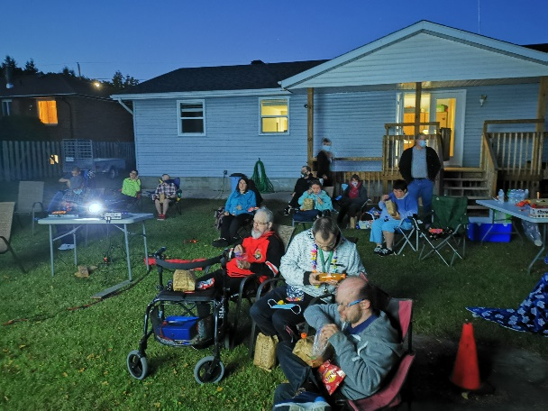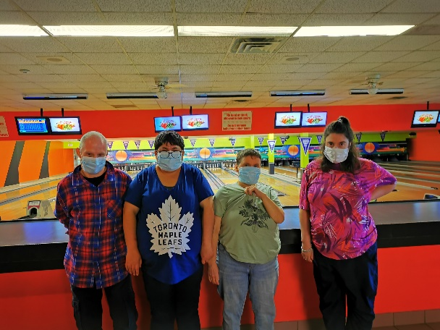

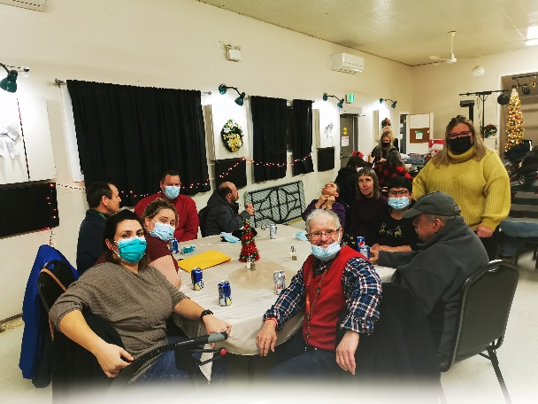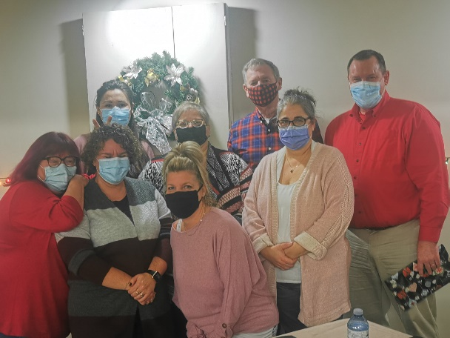

Pictorial Year in Review 2021/2022 Continued

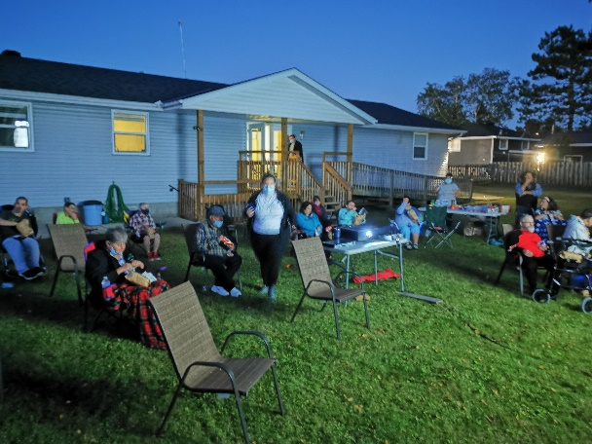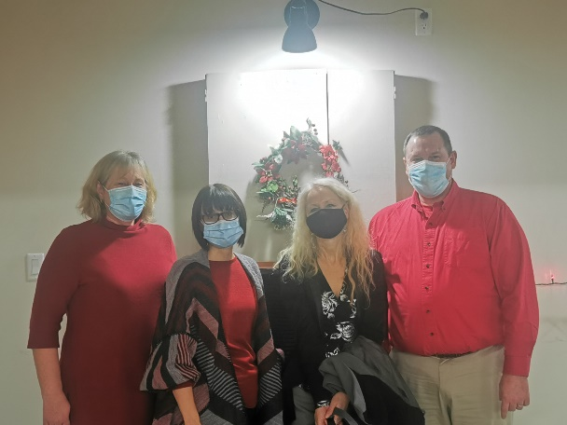
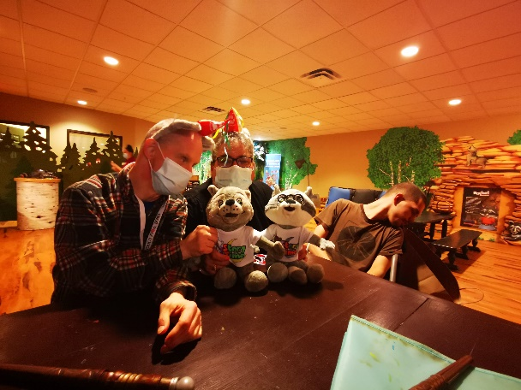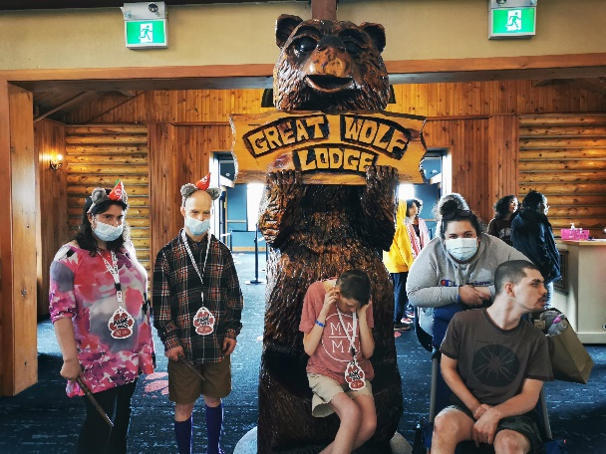
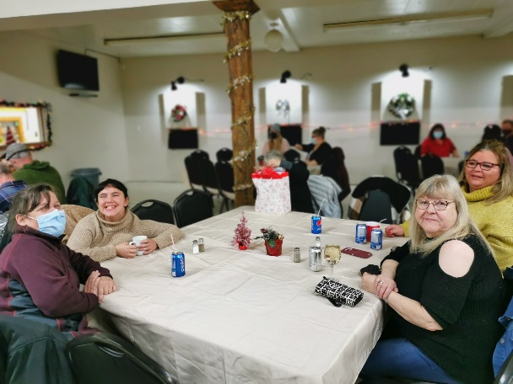

Pictorial Year in Review 2021/2022 Continued
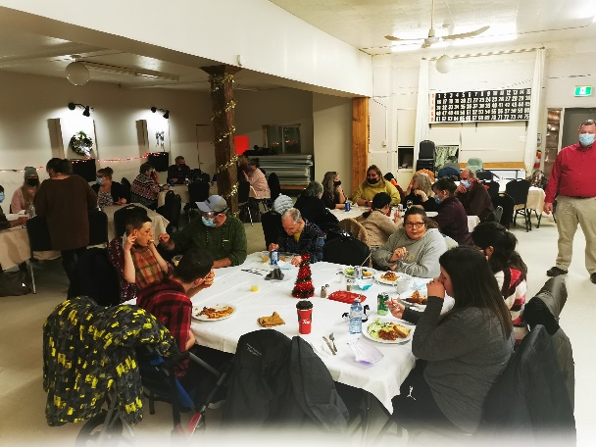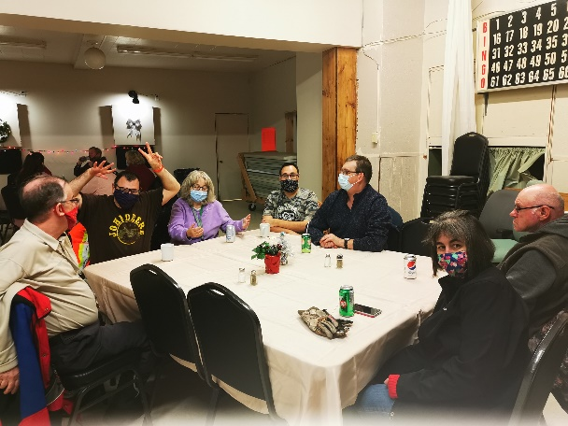
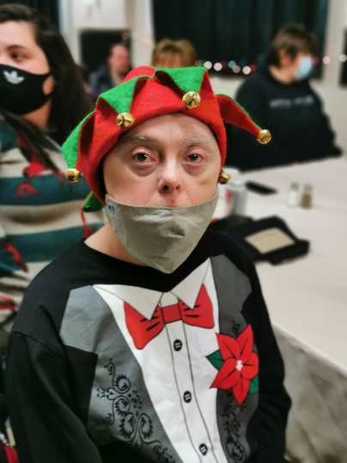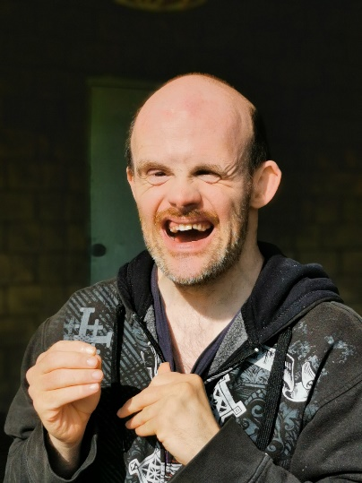
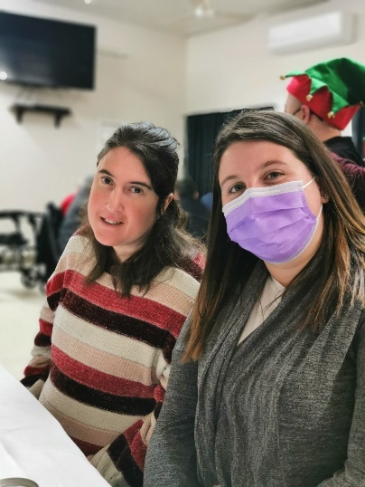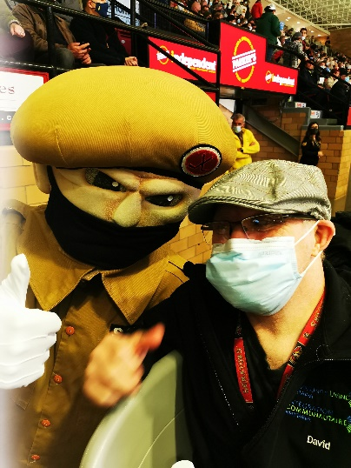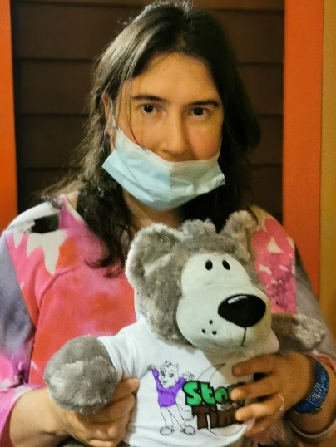

Pictorial Year in Review 2021/2022 Continued
