2022/23

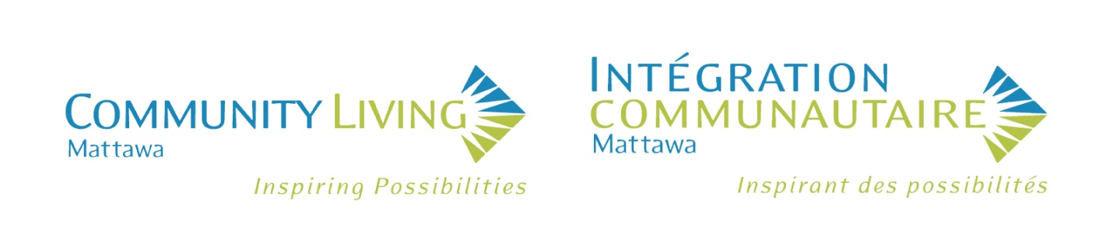

ANNUAL REPORT

Vision Statement

That all people are treated with respect, and live and participate as valued members of the community.

Mission Statement

To support people with developmental disabilities in living independently and participating fully in their community.

Our Values

Awareness – We value the education of the community on the rights and contributions of people with developmental disabilities and the services available through Community Living Mattawa.

Communication – We value the sharing of ideas and concerns in a manner that is respectful, open, honest, two-way, non-judgmental, and is in a language that is understood by everyone.

Inclusiveness – We value a community that accepts and includes everyone equally.

Individual Choice – We value the right for all people to make their own educated choices and to make decisions about the supports and services they receive.

Integrity – We value a workplace where services are provided in a manner that is honest, truthful, and respectful.

Partnerships – We value meaningful connections with others within our community.

Respect – We value the appreciation of all people’s abilities, qualities, characteristics, and goals.

Teamwork – We value working together to achieve a common goal (our Mission).

Board Chair 2022-2023 Annual Report

Good evening everyone and welcome to the Annual General Meeting of Community Living Mattawa (CLM). Thank you for taking the time out of your schedule to be here with us tonight.
This is the 54th year for Community Living Mattawa and it is my honour to serve as the Chair of the Board of Directors which is comprised of seven volunteers from our community who represent a variety of backgrounds and experiences. The Board meets monthly, except for the two summer months, and is responsible for oversight of the performance of CLM as it relates to policy, finances and achieving its purpose, goals and objectives.
Each year the Board hosts various fundraising activities and assists CLM staff in planning and participating in these events which enable our Consumers to participate in recreational activities and acquire needed items not covered by government funding. This year, in addition to our traditional two BBQs and Yard Sale, CLM held a very successful 50/50 draw, and two new fundraisers for CLM: A Texas Horseshoe Tournament in October and a Spring Fling Casino and Dance in May. Our first-time Texas Horseshoe Tournament was very successful with 30 teams of 2 people in each, and included a silent auction and the draw for the 50/50 raffle. We will be hosting our 2nd Annual Texas Horseshoe Tournament on Saturday September 9th…we hope you will sign up early and not be disappointed! Our Spring Fling was also a success and it was a joy to see our Consumers and guests together dancing, playing casino games and enjoying the midnight food! We are grateful to the community members who attended these events and those community businesses and individuals who donated items and services which assisted in these successful fundraising events.
Community Living Mattawa employs 41 dedicated full-time, part-time and casual staff who ensure that our Consumers are safe and healthy and provide various programs for each of them. Our staff have worked under very difficult, stressful conditions over the past three years and have finally been able to return to some sense of normalcy. The Board initiated an Employee Satisfaction Survey in the fall to give the staff the opportunity to share with us their thoughts on working for Community Living Mattawa. We are pleased that the majority of employees participated in the survey and it showed overall that our employees enjoyed working at CLM. There were however, as in most surveys of this nature, some issues identified where there could be improvements and we have asked the Executive Director and Management Team to address those items so that Community Living Mattawa is an even better place to work. We plan to conduct another similar survey in the future. Thank you again to each of our employees for your dedication and professionalism in assisting our Consumers throughout the year.
In December the Board was again excited to host the CLM Christmas Dinner with our Consumers, staff and guests. All the Board members look forward to this event and to distributing the gifts to each Consumer and staff member. This year the highlight was the donation and presentation to CLM of beautiful hand-made quilts presented by Diane Gallupe. Diane provided these quilts so that each Consumer living in our residences could place one on their bed. Thank you so much Diane!

Board Chair 2022-2023 Annual Report cont’d

This year Community Living Mattawa participated in Community Living Month in Ontario during the month of May. The Mayor and Council of the Town of Mattawa passed a proclamation naming May Community Living Month. A ceremony was held on May 1st at the Mattawa waterfront in front of Big Joe Mufferaw where Mayor Raymond Belanger and Deputy Mayor Mathew Gardiner and a number of Consumers, staff, guests and Board members gathered to hear the Mayor read the Proclamation and make some remarks commending Community Living Mattawa, followed by remarks from David Spencer our CLM Executive Director. Following the short ceremony, participants enjoyed cupcakes that were made with icing in the CLM colours, blue and green. Big Joe was lit up each night in May in those CLM colours, and blue and green light bulbs were given out to anyone in the community who wished to “shine a light” on Community Living.
The Board is currently working with the Executive Director and a Law Firm to review and amend our CLM Policy and Bylaws to conform to the new Ontario Not for Profit Corporations Act. When finalized and approved, our documents will be sent to the Canada Revenue Agency as is required to maintain Community Living Mattawa’s charitable status.
I am truly grateful to our Consumers, their families and friends, our Executive Director, Staff, our community businesses and individuals and our Board Members who continue to work together so that the Board may continue to assist Community Living Mattawa in its mission to support people with developmental disabilities in living independently and participating fully in their community. Thank you.
Respectfully Submitted by:
Wayne Cotgreave
Board Chair

Executive Director 2022-2023 Annual Report

The 2022-2023 fiscal year was another challenging year as the agency continued to navigate its way through the worldwide pandemic. Through good teamwork between the frontline employees and the Management team, Community Living Mattawa was able meet the changing requirements associated with COVID-19. The agency was able to maintain the relative health of the employees and the people with whom we support and was able to maintain full programming in all program areas for the entire year and continued to provide high quality services to the people we support.

During 2022, both Group Homes were declared in outbreak during the year and approximately one third of the agency’s employees contracted the virus and were required to self-isolate. The presence of COVID-19 resulted in an organizational high in the number of Serious Occurrences that the agency declared with the Ministry. In addition to the Serious Occurrences related to COVID-19, the agency saw a number of people who receive support hospitalized for a variety of health-related issues. This is an area that the frontline employees and the Management Team are monitoring closely.

Executive Director 2022-2023 Annual Report cont’d

The agency’s success, stability, and quality supports can be attributed to the many caring people that work for Community Living Mattawa both as employees and as volunteers. The frontline employees are dedicated people who have the best interests of the people we support at heart. Many employees covered for each other when people were sick and provided excellent care when someone they supported was sick. The employees endured all of the COVID-19 protocols in order to maintain their health and the health of the people they were supporting. Though there was illness within the organization, it was controlled by the best practices demonstrated by the frontline employees. I thank the employees for their work and dedication.

The Management team consists of strong leaders that work diligently to ensure the employees and the people we support have what they need to succeed. The Management team supports and covers for each other, so that programs continue to run smoothly. They offer support to each other, creating a cohesive team that keeps the organization moving toward its mission and vision. I thank the Management Team for their hard work, dedication, and support throughout the past year.

In addition to managing the workforce during the issues associated with the pandemic, the agency also managed an ongoing staffing shortage that is affecting all Developmental Service agencies across the Province. Recruitment efforts continued throughout the year, with participation at numerous job fairs and hosting several in-house career days. The results brought in a few new employees. Canadian Career College also held a Personal Support Worker certification program in Mattawa. One of the qualifications was to complete a community placement. Community Living Mattawa hosted one student who joined the staff team following the completion of her course. The agency continues to explore other ideas for recruiting new employees in an effort to meet its staffing needs.

Despite the challenges over the past year Community Living Mattawa still has an incredibly dedicated team. This dedication can be seen in the number of Service Award recipients being recognized in 2023. This year, the agency recognizes 6 employees for their years of service. 2 employees for 5 years of service, 2 employees for 15 years of service, 1 employee for 20 years of service, and 1 employee for 25 years of service. The longevity of employment for our employees demonstrates their commitment and care for the people they support. Everyone within the organization, thanks them for their years of service.

The Board of Directors consists of a group of volunteers that dedicate their time and energy to ensuring Community Living Mattawa is a strong and viable organization. The Board managed the agency’s risks during the pandemic and made sure the policies and practices of the agency maintained a high standard of care and support. In addition, the Board oversaw the financial health of the organization and raised money through its fundraising efforts to provide opportunities for the people we support in the community. I thank the Board for all of their support and leadership throughout the past year.

This past year saw the return of the organization’s ability to host fundraising events. The agency held two successful Community Barbeques, a Yard Sale, a 50/50 Lottery, and its first Texas Horseshoe (Washers) Tournament. Once again the community of Mattawa supported the agency in its fundraising efforts, helping to raise over $8,000 in the last fiscal year.
This past fiscal year, the agency’s base funding from the Ministry remained unchanged from last fiscal year. This provides adequate funding to run programs, but does not keep pace with any

Executive Director 2022-2023 Annual Report cont’d

cost of living increases. In addition to the agency’s base funding, the Ministry did make the Wage Enhancement Funding for frontline employees that was introduced in 2021, permanent. So, all frontline employees that provide direct support received a permanent wage increase. This is great news for the majority of CLM’s employees, but unfortunately, this increase did not extend to all employees within the organization. Developmental Service agencies continue to advocate for universal wage increases and base budget increases, but the wage enhancement is a good first step within the Developmental Services sector.

Community Living Mattawa continued to meet its Ministry mandate to have the capacity to provide services in French. Using the updated policy as a guide, CLM improved its consumer intake process so that people receiving service were asked for their preferred language in order to support them in the way they chose. In addition, training on French Language was expanded for employees through online training modules. Finally, any public documents were translated so that they were available in both French and English. Our plan continues to develop as implementation slowly takes place across the agency.

Community Living Mattawa completed their annual Ministry Compliance inspection in November 2022. The inspection re-introduced the full compliance review following two years of modified inspections due to COVID-19. The agency had both of their Group Homes inspected. The results of the inspection were one item of non-compliance. This was corrected within 10 days and the agency received its letter of compliance, stating that the organization was in full compliance with Ministry policies and procedures. I would like to thank the frontline employees and the Program Managers for their preparation for the inspection, their participation during the inspection, and their follow-up after the inspection. Their work helped CLM reach compliance.

One of the highlights of the past year, was the re-introduction of the agency’s annual Board sponsored Christmas Party. This event was held at the Royal Canadian Legion in Mattawa and was an opportunity for the people who receive support, their family members, the employees, their family members, and the Board to celebrate the season together. It was a great sign that the effects of COVID-19 were finally starting to lessen.

As the agency continues to move through the end of the pandemic, it prepares for its future. One initiative the Ministry implemented in 2022 was changing the name of Residential Services to Supportive Living Services. This name change represents a positive step for the sector and another step away from the Residential facilities of the past. As a result, Community Living Mattawa changed the title of the Program Manager of the Group Living and Supported Independent Living services to the Supportive Living Manager. This better reflects the vision and mission of the agency.

Recently, the Ontario Government introduced its plan for the future of Developmental Services, called The Journey to Belonging. This plan calls for more individualized support options for people with developmental disabilities and for the expansion of individualized funding. This creates an opportunity for Community Living Mattawa to adapt its services to meet the individual needs of the people we support. This approach will allow for more community participation and further development of skills for independence. In the coming months, the agency will begin the process of updating its Strategic Plan to meet the changing needs of the sector. We will be reaching out to stakeholders to provide their input into the future directions of the organization.
Community Living Mattawa has persevered throughout the pandemic and has shown that it has a strong team across the organization.

Executive Director 2022-2023 Annual Report cont’d

The agency will continue to work together to meet the challenges of the future and will continue to provide high quality service with the goal of assisting the people we support to participate fully in their community.

Respectfully Submitted by:
David Spencer
Executive Director

Community Services Manager 2022-2023 Annual Report

I am pleased to share that it has been an interesting and exciting year for Community Services as a whole! Keeping our agency’s Mission at the forefront has helped us move forward as we work our way through the impact the pandemic has had on the people we support, and on our services.

As time progresses, we continue to see how important it is that overall services be provided in a flexible and creative manner. We continue to see the importance of providing learning opportunities in small group settings, as well as the benefits of providing individualized supports. Our remarkable consumers continue to inspire us to provide services to the best of our ability. When we look and listen closely, we realize that our consumers are the ones educating us about service quality and flexibility. Applying what we learn from them, as we continue assessing our methods of providing supports is very important. It is truly rewarding to see someone enjoy the experiences and services we provide!

As our agency has been affected by the country-wide human resource shortages, we continue to explore innovative opportunities and options that will increase and maintain stability. Our efforts to increase stability also involved assessing our current staffing structure and scheduling needs. As a result, the agency purchased a Human Resources Information Management program called GoEasyCare. Though the time commitment to implement the software was extensive, we are now seeing positive benefits of moving to this electronic based system. It has created opportunities to establish more regular work rotations for several employees, as well as provide more opportunities for employees who would like to work additional hours. The program is also providing all employees with quick up-to-date access to their scheduling information. Though it has been a big adjustment for everyone, overall moving to an electronic based system will greatly benefit all employees and the agency as we move forward.

This past year the Board of Directors conducted an Employee Survey that focused on collecting information about different areas related to the agency. The survey was extremely beneficial in identifying key areas where improvements could be made. One of the identified areas focused on communication, and what the agency could do to improve upon it. Because of this feedback, the Program Managers have begun carrying out regular team meetings for each of the main programs. In addition, plans to increase individual meetings with our employees are under way for the 2023-2024 fiscal year. Woking together to improve overall communication in the workplace will create stronger teams, and a stronger agency as a whole.

I would also like to recognize the dedication and hard work carried out by our Joint Occupational Health and Safety Committee Members this past year. The committee members work diligently to encourage others to engage in safe practices, and to carry out the monthly inspections. Every

Community Services Manager 2022-2023 Annual Report cont’d

year, the committee is also responsible for conducting a review of our Health and Safety program, which consists of reviewing agency policies and safe work procedures, and conducting an all encompassing review of the Health and Safety Manual. With ever-changing legislation and changes the agency experienced during the pandemic, the committee completed a very thorough review this past year. The exercise was lengthy and resulted in several recommendations to update the manual, and some of our processes and procedures. We are very fortunate to have such a dedicated committee that helps maintain our agency’s high health and safety standards.

Community Services consists of four programs, which include Community Outreach Services, Transitions Services, Children’s Respite Coordination and Passport Services. Community Outreach Services provides tailored individualized support in a ‘one-on-one’ setting to pursue individual interests and needs, learning opportunities and classes in small group settings, as well as opportunities to foster social experiences and relationships while participating in our community and those in the surrounding area. This model has demonstrated great benefits to the people we support. Our goal for the 2023-2024 fiscal year will include conducting an evaluation of this framework with the intention of making continuous improvements. Currently we support 21 people, however we anticipate a total of 24 people will be supported before the end of the next fiscal year.

Our Transition Services are currently supporting two young adults, and we have two others who will also begin receiving this service in the new fiscal year. This service is designed to support adolescents and young adults with a developmental disability, to prepare and plan for their transition from children services to adult services. This consists of supporting them and their caregivers to navigate the application process with Developmental Services Ontario (DSO), the application process with Ontario Disability Support Program (ODSP), and develop a Person Directed Plan. The ultimate end goal is to support them in finding the adult service that will best meet their wants and needs.

Children’s Respite Coordination Services continues to support families in our community and catchment area. Our Coordination Services is designed to support them identify their needs, develop Respite Plans, complete Respite Funding applications, and access beneficial resources. In the 2022-2023 fiscal year, Children’s Respite Coordination saw a fifty percent increase in the number of children who applied for respite funding and services. At the end of the fiscal year, CLM was supporting 12 children in total, and we continue to receive more applications for service. As this service is available to children with a developmental disability up until they reach 18 years of age, our coordination services also include offering Transition Services anywhere after they reach the age of 14. This transitional planning is very beneficial in assisting families prepare for the transition from children services to adult services. Though not all families take this path, we do highly encourage it. During the course of the Pandemic, families were faced with an extreme shortage of suitable Respite Workers to support their children. This is still a challenge many families are facing, and they are looking for more support from our agencies in trying to recruit and hire Private Respite Workers. Respite Coordination services continues to support families with this.

In 2022-2023, our agency supported 26 people in Passport Services. The services consisted of supporting consumers manage their individualized funding, and submit their expense documentation for reimbursement. When the Ministry of Children, Community and Social Services temporarily expanded the list of admissible expenses in 2020 regarding how people’s

Community Services Manager 2022-2023 Annual Report cont’d

funding could be spent, it provided consumers with additional opportunities to use their funding. Under these temporary measures, people could purchase items that would be of benefit to them
while they remained safely at home. It provided them with a way to pay for the technical means to stay connected to friends and family. People were able to purchase items such as fitness equipment, electronics and technology type equipment and services (such as Internet service), sensory and hobby supplies, and personal protective equipment. The majority of the people we support with their Passport Funding took full advantage of this provision. The Ministry extended these temporary admissible expenses up until March 31, 2023. Similar to the challenges families receiving Respite Coordination are facing, consumers receiving Passport funding are also having difficulty finding suitable private Support Workers. Though Community Living Mattawa has felt the effects of the country-wide human resource challenges, we have begun exploring ways to expand our support capabilities for these consumers. Though we are still in the initial development stages of this framework, we believe this direction will help meet the needs of theses consumers. It is anticipated that a new Passport Support framework will be implemented in the 2023-2024 fiscal year!

We are very fortunate to have the means to provide such a wide range of services to many members of our community. Our services are provided with kindness and care by our dedicated employees. Their compassion, dedication, flexibility and commitment is admirable, and I would like to take this opportunity to recognize them. They are an integral part of the Community Living Mattawa team, and for carrying out our agency’s Mission ‘to support people with developmental disabilities live independently and participate fully in their community’. I look forward to working with the Community Living Mattawa team over the next year carrying on with this Mission.

Respectfully Submitted by:
Tammy Boudreau-Bangs
Community Services Manager

Supportive Living & Quality Assurance Manager 2022-2023 Annual Report

This has been another exciting year in the Supportive Living and Quality Assurance Programs. We have seen many changes and we anticipate further changes ahead as we provide individuals with the supports they need to live more independently in the community.

Our Supported Independent Living Program (SIL) has embarked on a journey to change the manner in which it provides supports. Over time the program had evolved in a manner that did not provide supports consistently due to COVID restrictions. Some consumers were over-
supported, creating dependencies, while others were not able to access the supports that they wanted or needed. By adjusting our support model, all of our consumers now feel they are receiving sufficient supports and are becoming more independent within their community by engaging on a more regular basis. We welcomed a new consumer in the fall of 2022 and we are also actively working with Developmental Services Ontario (DSO) to welcome more people into our SIL program.

Community Living Mattawa is becoming more visible in the community by having signage on our buildings and putting CLM out there in the community. Being recognized by the Town of

Supportive Living & Quality Assurance Manager 2022-2023 Annual Report cont’d

Mattawa on its own goes to show all of us that we are making a difference not only in the lives of the individuals we support but within our community as a whole. The SIL office’s main entrance is now open during the work week for community members to reach out and ask questions.

The Brydges Group Home is home to five (5) individuals now, all with varying needs and personalities. Basement renovations increased the space in the building and resulted in a better living space for an existing consumer in the home, this resulted in a vacant room. The fifth consumer came into the home as an urgent response from our Supported Independent Living Program, he fit right into the home as though he had been living there his whole life.

Over the past year we have brought in opportunities for partnership with Community Living North Bay (CLNB), Near North District School Board (NNDSB), Go Easy Care and Canadore College. Some highlights of our partnerships that I would like to mention are that our SIL program is currently working on a pilot project called, “THE SHIFT”. The concept of “THE SHIFT” is to have multiple organizations work together to best support individuals with complex needs who do not fit into one specific support system. Currently, the focus with “THE SHIFT” is to best support individuals who have fallen or are falling through the cracks of the system and have come to CLM with substance abuse problems, mental health and developmental disabilities. “THE SHIFT” is so impactful and hits close to home right here in Mattawa with some of our very own consumers. I am so proud that CLM is a part of “The SHIFT”, as it takes just one person to create change and we are working together to help with this change. Below I have added in a small piece of what “THE SHIFT” is about for you to have a clearer understanding of what we will be working towards in the coming year.

“This is an opportunity for you to save a life.
That sounds dramatic, like an attempt to sell you something, but it isn’t.
This is THE SHIFT. With a mindset shift - just a tiny shift in your viewpoint - you can save a life.
It’s the defining characteristic of harm reduction … saving lives. But it requires THE SHIFT from a mindset of: This or that; yes or no; worthy or unworthy - ready or not.
It is a chance to save the lives of those clinging to the edges of our world — those who do not fit the mold of the “perfect victim,” the “perfect patient” or even someone to invest time and resources in when there are so many desperate for help. Tiny, actionable changes — a shift in your mindset — and you moving forward with an eye to harm reduction (rather than perfection) and you can save a life. More than that, you can give someone their dignity back.
We may not get to choose the path our lives take, but to do so with dignity is a basic human right.
Harm reduction is not about happy endings. Once you experience THE SHIFT in your mindset, you’ll see it too. There is no perfect solution, but there is one that ensures that everyone’s needs are met, even if they are not quite what you expected.”

If you would like me to share more information about THE SHIFT with you, please let me know.

Our commitment to improving training and providing additional opportunities for training, as well as seeking feedback from all employees through more regular team meetings has shown us that the strength of our teams. The employees are truly committed to the people we support. The team meetings have been very well received by the employees, with some employees

Supportive Living & Quality Assurance Manager 2022-2023 Annual Report cont’d

choosing to attend on their days off or staying after their Night Shift to participate. The meetings have allowed the employees to work together and be on the same page in order to provide the best support for the consumers. Team meetings have been scheduled for the next year with a different location each month. One-on-one meetings with the employees is next on my agenda to ensure they are feeling well supported within their job scope.

In December of 2022, the NNDSB approached us with the opportunity to become an employer partner for students during their placement. The arrangement would be to have a placement student come to CLM to complete their community placement hours. This partnership is providing us with opportunities for soon-to-be graduates to learn about who we are and what we do and for us to learn about the student and whether they would be a good fit as an employee of Community Living Mattawa. I am pleased to say that we had one successful placement student who has been a great asset to our agency since completing her PSW course and placement. We have also had success with hiring a placement student from Canadore College - Mental Health and Addictions Program.

Currently our staffing level is adequate for base coverage within all programs but we still need to address our coverage during employee absences, covering these situations will be our next recruitment goal.

In March 2022, Community Living Mattawa hired a Support Worker Apprentice, after some difficulty with technology she has now successfully completed her first course. She is about to start her second course. In addition to the Apprenticeship Program, CLM explored other educational and training options available for new employees that do not have post-secondary education. The idea of running and in-house training program emerged and we connected with CLNB regarding their in-house training program. CLNB developed a Direct Support Professional Certificate Program for their workplace. CLM purchased this program and is planning to launch their own program by fall 2023. The program has ten (10) specific areas of development and hands on training to assist employees to gain the knowledge they need to be successful Support Workers. This program will expand the number of potential employees available to CLM.

Community Living Mattawa passed its annual Ministry Compliance Inspection in November 2022 with one note to review. Through this process, we were reminded of the importance of communication between employees and developing and maintaining quality documentation and follow-up systems within the agency. As a team, we are all committed to improving our documentation and reporting systems, we will continue to work together to improve our systems as times change.

One document that has been implemented is the Supported Independent Living Service Agreement, as I found this was a lacking piece within the program. This document outlines what supports a consumer receives, how often they receive supports and if they require any additional services. This Service Agreement has been well received by the consumers as they have more opportunity to voice what kind of supports they would like and how often they would like to receive them. This agreement helps ensure that we provide the best possible services for our SIL consumers and have discovered that some consumers are looking for more supports

Supportive Living & Quality Assurance Manager 2022-2023 Annual Report cont’d

while others would like less. This document will be reviewed on an annual basis with the consumers, or sooner if changes are needed or if they request a change to the agreement.

The Management Team also introduced One Page Profiles for the employees. This document allows the employees to create a page of their likes, dislikes, anxieties, etc. This document assists the management team with pairing the consumer up to ensure the best possible supports. The Employee One Page Profile has been well received. Currently, we do not have a template for the Employees’ One-page Profile because I wanted the employees’ to have control

of what they are sharing or not sharing. This document is meant to be as unique to the employee as they want it to be.

Dementia Non-Violent Crisis Intervention Prevention (CPI) Training was introduced in 2022 to assist the employees in their support of consumers developing onset Dementia. This type of training was requested by employees so they could better support the growing needs of consumers with onset Dementia. This training adds an extra layer of knowledge to our employees allowing them to feel more at ease when supporting a consumer with different levels of Dementia. Dementia CPI gives CLM an opportunity to work with all of our employees on further developing their de-escalation skills, further understanding their learning styles, and creating meaningful discussions around best practices and support strategies for the consumers.

There were several upgrades to our buildings in the 2022-2023 fiscal year. The major renovation at 1000 Brydges was finally completed after being stalled for three years due to COVID-19. The stairs to the basement were finished creating better access and allowing one consumer to move their bedroom downstairs, giving them more space. In addition, a new air conditioner was installed and the ductwork upgraded to allow for more efficient airflow throughout the home. 170 Bissett had an upgrade to their furnace as well as a gazebo added to the backyard to allow for the consumers to utilize the space more often. 250 Tenth had two new furnaces installed. New signage was installed at 250 Tenth and 533 Valois.

While it has been another busy year for Community Living Mattawa, we look forward to the changes and challenges ahead. We will continue to evolve with the times by improving our own knowledge and skills and those of the teams as we work towards a common goal to provide better supports to our consumers, to achieve independence and community inclusion.

I would like to acknowledge all employees for the outstanding work they do, each, and every day. They strive to provide the best quality supports to the consumers on a daily basis, sometimes they may feel this goes unnoticed but I’m hear to tell you we notice your hard work and dedication to the consumer and Community Living Mattawa as a whole, we couldn’t do this without you. Thank you.

Respectfully Submitted by:
Tanya King
Supportive Living & Quality Assurance Manager

FINANCIAL REPORT ACTIVITIES 2020/21
Audited Financial Statement Available upon Request

Service Awards

Community Living Mattawa would like to recognize and congratulate the following employees for meeting service milestones:

Jennifer Innes 5 years
Travis Martin 5 years
Shelly Condie 15 years
Pam Nolan 15 years
Sharon Maxwell 20 years
Tammy Boudreau-Bangs 25 years

Board of Directors

Wayne Cotgreave – Board Chairperson Monique Antoine – Vice Chairperson

Crystal Backer – Secretary/Treasurer Chantale Michaud – Director

Lyndee Cicalo – Director Sabrina Poullas - Director

Amy Leclerc - Director
Donors (As of the 2023 Calendar Year)

Community Living Mattawa would like to recognize and thank the following donors for their generous support:

Corporate

Dr. Bryan Williams | Caisse Populaire, Mattawa | Gin-Cor Industries
J.E.Y.’S Shredding | Janveaux Forest Products | Le Voyageur Inn
Mattawa Pharmacy | Mattawa Senior Citizens | MedPro Direct
Municipality of Mattawan | Northern Energy Systems | Q2 Distribution
R. Boudreau Construction | Scott’s Discount | Township of Papineau-Cameron
Wilson’s Builders Supplies | Yes We Do Coffee | Kendall, Sinclair, Cowper, Daigle, Holden

Personal

Monique Antoine | Karen Atkinson | Beth Bangs
Tracy Bellaire | Carmen Boudreau | June Brayshaw
Noella Burke | Lyndee Cicalo | Wayne Cotgreave
Angela Cotnam | Claudette Larocque | Pierrette & Dan Leclair
Bob & Fran Lessard | Barbara Mitchell | Vala Monestime-Belter
Anna Moreau | Helen & Larry Novack | James O’Hare
Muriel Pecore | Joffre Ribout | Roly Ribout
Pauline Sloan | Lois Spencer | Gerard Therrien
Per Voldner | Francine Whalley | Jack & Vicky Wilson
Corinne Groulx

Pictorial Year in Review 2022/2023

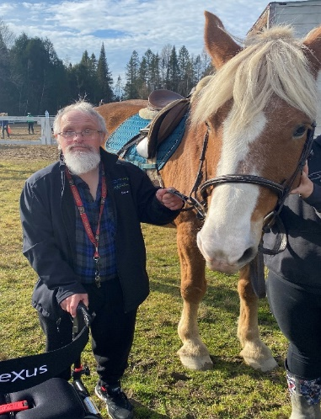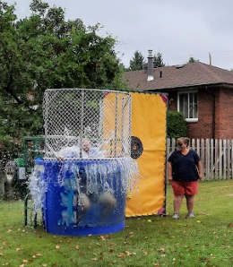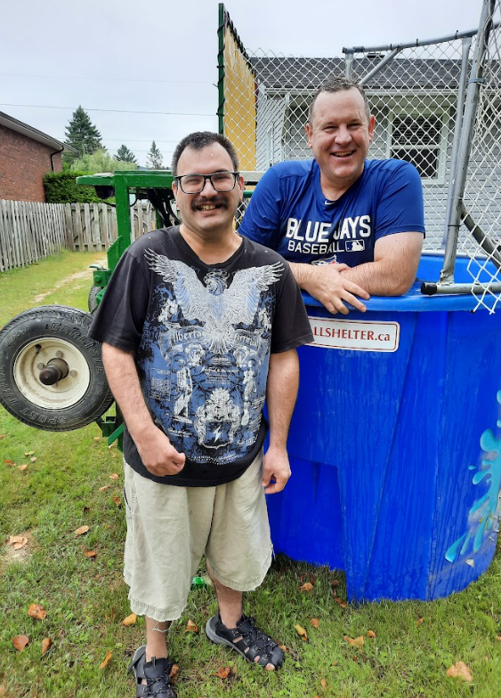

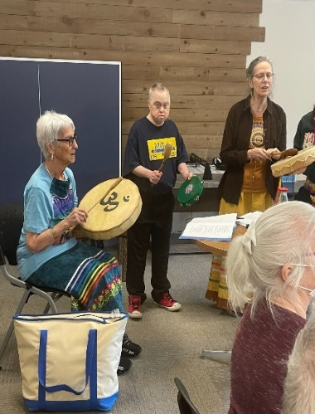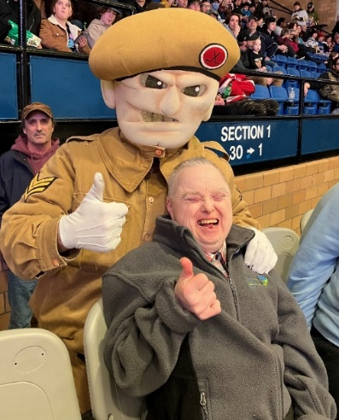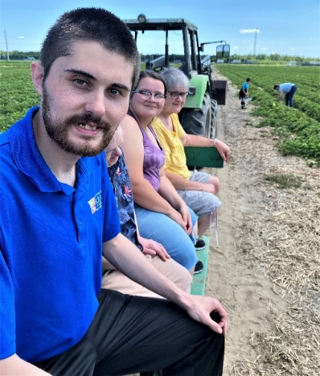
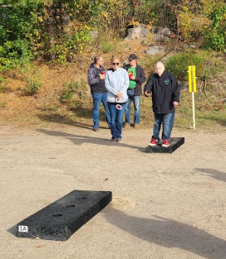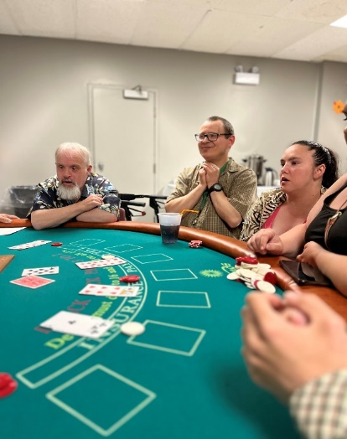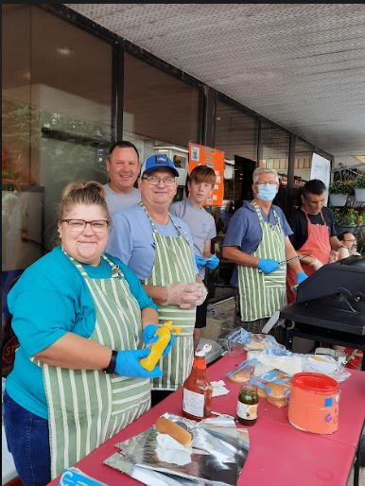

Pictorial Year in Review 2022/2023 Continued

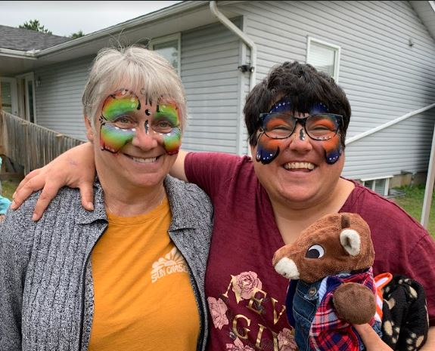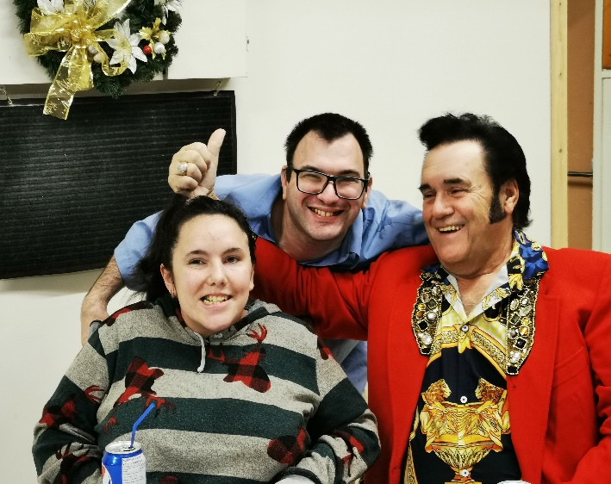

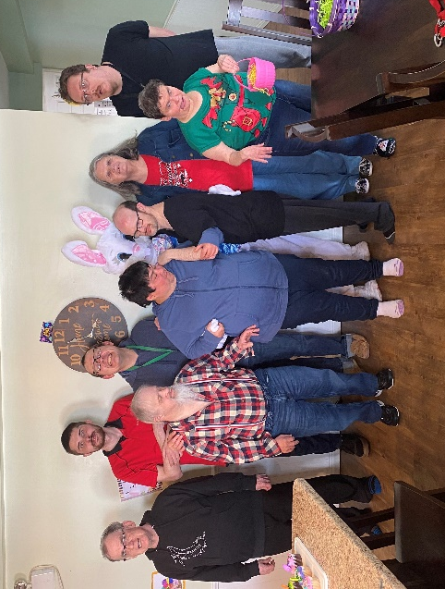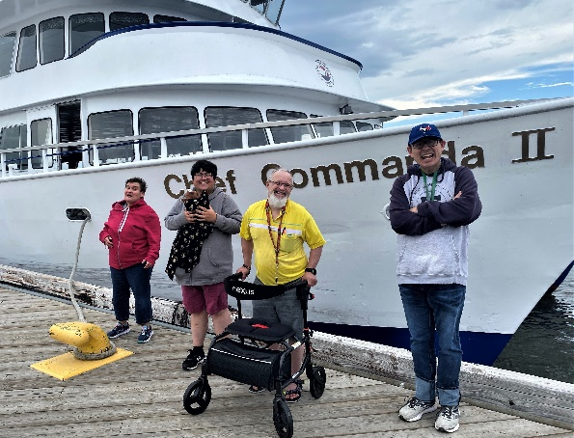

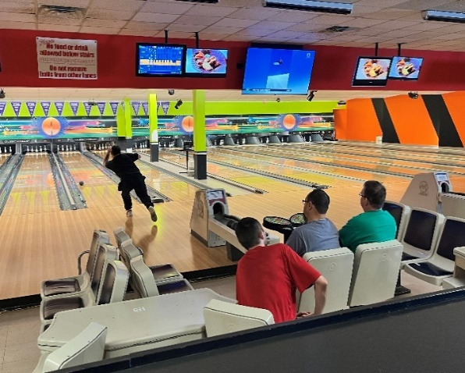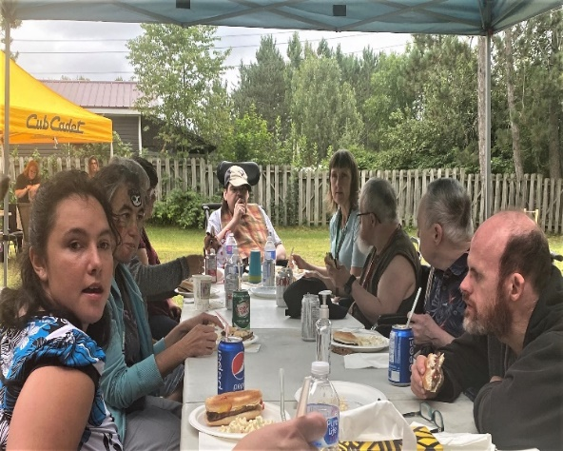
Pictorial Year in Review 2022/2023 Continued

